**NBA Injury Data from 2015-2025:**

**Data Visualization of Player Injuries**

William Wright

Department of Information Technology, Purdue Global University

**Author Note**

Correspondence concerning this article should be addressed to William Wright, Department of Information Technology, Purdue Global University, 2550 Northwestern Avenue, Suite 1100 West Lafayette, IN 47906. E-mail: williamwright@student.purdueglobal.edu

**NBA Injury Data from 2015-2025**

This season's NBA playoffs for marked by numerous severe and potentially career altering injuries to a number of star players from the last two NBA finals, including 3 all-nba players suffering achilles tears– Damian Lillard, Jayson Tatum, and Tyrese Haliburon. This type of injury is considered severe and potentially career altering, with an estimated recovery between 12 to 18 months before they can return to play. Both Haliburton and Tatum are 27 or younger– a player is generally considered in their prime between 27-30 (Salmeh, 2023)–and now face a long road to recovery with questions of if they will be able to get back to the same level prior to the injuries.

Sports analysts have begun to raise questions of the rise of serious injuries in the playoffs especially those who are considered “all-stars” within the league (Reynolds, 2025). One theory for the rise in serious injuries in the playoffs include “wear and tear”, as the NBA season has continued to expand with an 82-game schedule and the addition of an in-season tournament and play-in games (Rosenstein & Srinivasan, 2025). In addition, players may be required to play multiple back-to-back games within a season along with flights across the US and occasionally internationally.

The purpose of this research project is to review NBA injury data from the past 10 years and look for any hidden patterns, such as frequent injury types, season phases with high injury rates, season ending injuries, and whether rest has an effect on player health. Three measurable key performance indicators (KPIs) were identified for this project– injury type distribution, injury frequency, and season-ending injury count. Data was scraped from the website Pro Sports Transactions (2025) using a python script I designed based on the original code by Hopkins (2020).

The data dictionary for this project was generated based on the table provided by Pro Sports Transactions with additional categories created through python. The complete data dictionary prior to cleaning features:

* Date: The date the injury update was provided (e.g. 3/16/2019)
* Team: NBA team associated with the player at time of injury (e.g. Blazers)
* Player: The player who was injured (e.g. Damian Lillard)
* Acquired: Player returns to lineup (e.g. Damian Lillard)
* Relinquished: Player placed on injured list (e.g. C.J. McCollum)
* Notes: Narrative summary of injury, status, or update (e.g. placed on IL recovering from surgery on back)

Data was extracted using a python code that utilized BeautifulSoup and Selenium/undetected-chrome driver to scrape the HTML tables across the paginated results on the Pro Sports Transaction Site. Data was then cleaned with a python code I created based on Zuvkovic (2018) and collaborated on by ChatGPT (2025) and Google Colab AI (n.d.). The dataset of NBA injuries from 2015 to 2025 underwent a multi-step cleaning and feature engineering process using Python and its data manipulation libraries such as pandas, numpy, and re. Initially, the data was loaded from a CSV file and subjected to whitespace stripping and character decoding to correct encoding artifacts (e.g., “â€¢”, “Ã”). Date fields were standardized, and key text fields such as “Acquired” and “Relinquished” were used to construct a unified “Player” field. The “Team” names were normalized to title case, and date-related features such as year, month, and weekday were extracted for temporal analysis. To interpret injury severity, the notes were categorized into a custom duration type (e.g., “out for season,” “day-to-day,” “surgery”) using string pattern recognition, and corresponding estimated durations were mapped numerically. An “InjuryKeyword” was extracted using a predefined list of common injury terms to enable categorical analysis.

The script then attempted to construct injury duration records by analyzing sequences of transaction entries for each player and team. It calculated both the actual duration of injury and the number of in-season days missed, using June 15 as the standard season-end date if a return was not recorded. Injuries with no return transaction were flagged as presumed season-ending. The output from this injury tracking logic was merged back into the main dataset. To reduce duplication and noise, rows that represented return transactions were removed, and records were deduplicated using a combination of player name, team, date, and notes. The cleaned dataset includes final indicators such as “Month,” “DayOfWeek,” and complete duration estimates, and it was exported as a CSV file for downstream analysis and visualization. The cleaned dataset now includes these additional categories in the data dictionary:

* Injury Keyword: Injury category from the description that categorize the injury (e.g. achilles)
* Injury category: The category for injury duration (e.g. day-to-day, out for season)
* Year: Year of event (e.g.2022)
* Month: Month of event (e.g. March)
* Year and Month (e.g. 2022-10)
* Estimated Days Out from notes: an estimation based on injury category (e.g. 180 days)
* Injury start: Date injury was first reported (e.g 10-29-2022)
* Injury end date: Date when player was moved to “acquired” (e.g. 2-14-2023).
* Actual injury duration: Based on the difference between relinquished/acquired (e.g. 33 days)
* Day of week: Day of the week the injury event occurred (e.g. Sunday).

# 

# **Figure 1**

# *NBA Team Total Injury Events (2015-2025)*

# 

# *Note.* This bar chart presents the total instances of reported injury (injury events) for each NBA team across the previous 10 years, allowing for team-to-team comparison of total player injuries. This data could benefit NBA front office executives, athletic trainers, and NBA analysts as it demonstrates the franchises with the highest injury volumes, which may indicate concerns with training regimens or player management strategies.

# 

# **Figure 2**

# *NBA Injuries Over Time (yearly/by month)*

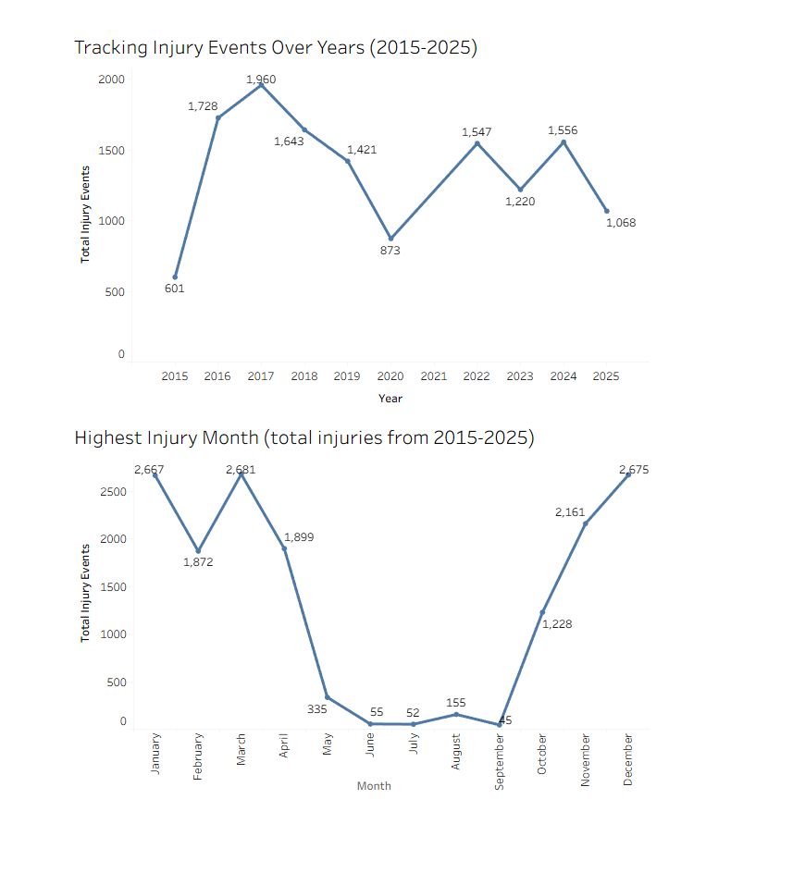

# *Note.* This visualization features a time-series line chart that tracks the total number of injury events recorded in each season from 2015 to 2025, highlighting peaks and drops across seasons and underscoring how external factors (e.g. COVID-19, condensed seasons) may affect injury frequency. The second graph This graph identifies the total number of injuries that occurred in each calendar month across all years, highlighting seasonal injury patterns. Coaching and training staffs, as well as sports medicine professionals, will benefit from identifying periods of heightened injury risk, highlighting when player load management may be critical.

# **Figure 3**

# *Most Common Injury Types (2015-2025)*

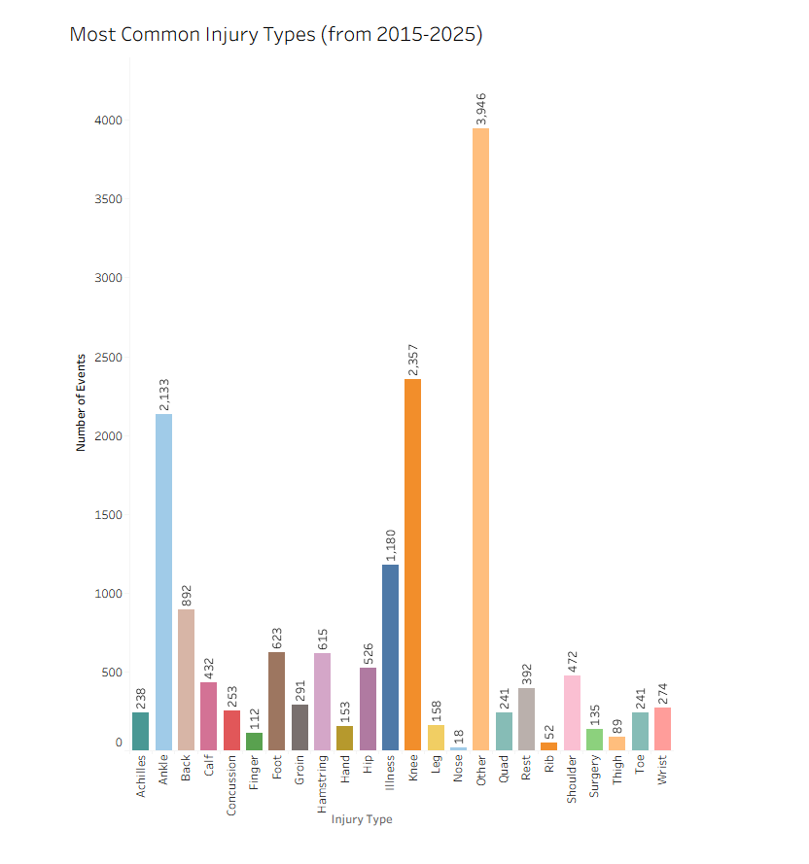

# *Note.* The bar chart categorizes and quantifies the most frequently reported injury types across all teams and years, showing which medical conditions were most prevalent from 2015-2025. Training and medical personnel will benefit from understanding which specific injuries may be most common: notably knee and ankle injuries. Other was the dominant category, as all undisclosed injuries were included as well as any injuries that did not meet the coded injury types. These categories do not factor in additional categories that the injury may also fall into (e.g. knee is not considered leg and vice versa) and was pulled directly from the note category.

# **Figure 4**

# *Comparing Total Injury Events to Player Rest by Team*

# 

# *Note.* The purpose of this visualization is to compare the total injury events by team with total rest instances reported by team. The second visualization quantifies all instances of a team listed “rest” as the injury keyword from 2015-2025. Notably, the teams with the most injury events over the last decade are also the teams utilizing rest events the most. The graph is aimed towards team medical staffs, player advocates, and league safety committees in response to the “load-management” debate that has gained traction in recent years,

# 

# **Figure 5**

# *Season Ending Injuries by Year (2015-2025)*

# *Note.* This time-series line chart plots all injuries labeled as “season ending” based on total count per year. The goal of this is to identify whether a rise in season ending injuries have occurred; however data is organized by year and not NBA season, which may skew data heavily. Of note, the COVID shortened year featured a very low count compared to the delayed and shortened 2021 season, which showed the second highest season ending injury count. This graph supports medical staff, NBA executives, NBA player association executives, and the league safety committee by showing volatility in season-ending injuries, with spikes in 2016 and 2024 requiring further investigation.

# 

# 

**References**

Basketball transactions search results. Pro Sports Transactions. (n.d.). https://prosportstransactions.com/basketball/Search/SearchResults.php?BeginDate=&EndDate=&ILChkBx=yes&InjuriesChkBx=yes&Player=&Team=&start=28100&submit=Search

OpenAI. (2025). ChatGPT (July 21 version) [Large language model]. https://chat.openai.com/chat

Google Colaboratory. (n.d.). Colab. https://colab.research.google.com/#scrollTo=GJBs_flRovLc

Hopkins, G. (2020, October 30). *gboogy / nba-injury-data-scraper*. GitHub. https://github.com/gboogy/nba-injury-data-scraper/blob/master/injury_scrapper.py

Reynolds, T. (2025, May 13)*. Injuries are becoming the story of the NBA playoffs. and not even the game’s stars are safe.* AP News. https://apnews.com/article/nba-playoffs-injuries-tatum-curry-22e9533b490480dc7f2c45e12f29d3cd

Rosenstein, G., & Srinivasan, S. (2025, June 24). *3 NBA stars hurt their Achilles tendons this postseason. is this injury becoming more common?*. NBCNews.com. https://www.nbcnews.com/health/health-news/achilles-tendon-tears-injuries-nba-playoffs-rcna214562

Salameh, T. (2023). An empirical analysis of prime performing age of NBA players; when do they reach their prime?. Bryant Digital Repository. https://digitalcommons.bryant.edu/eeb/vol16/iss1/14/

Zivkovic, J. (2018, November 23). Extensive NBA injuries Deep Dive Eda. Kaggle. https://www.kaggle.com/code/jaseziv83/extensive-nba-injuries-deep-dive-eda/report